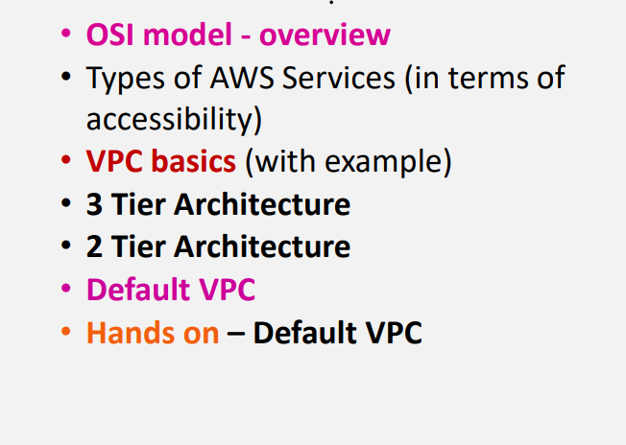

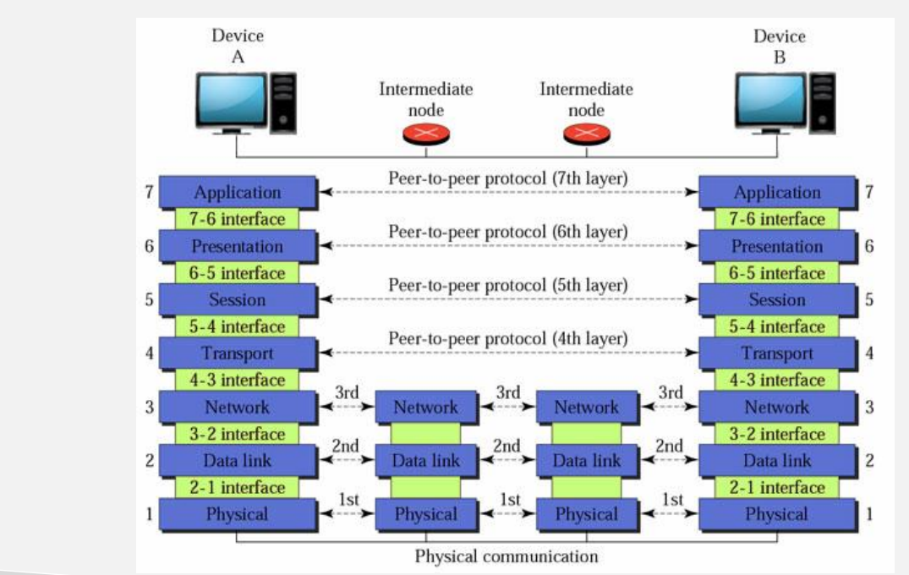

**OSI MODEL :Open system inter connection its one of the standard model for networking**

**Lets take example of whatsapp**

1. **Only 7 th step which you can do rest of the steps will automatically done based on 7th step**
2. **If you send a msg**
3. **6 th step will perform encryption**
4. **Session will create a session for that particular chat**
5. **Next 7th ,6th ,5th steps will be done in our mobile later the steps will continued in transportation part from source to destination**

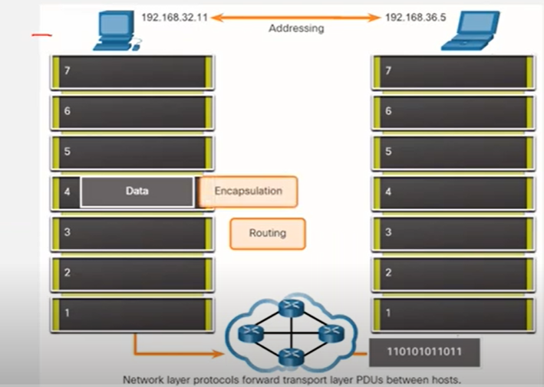

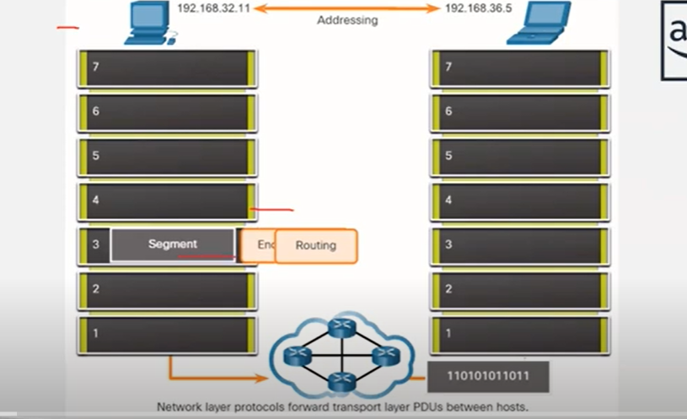

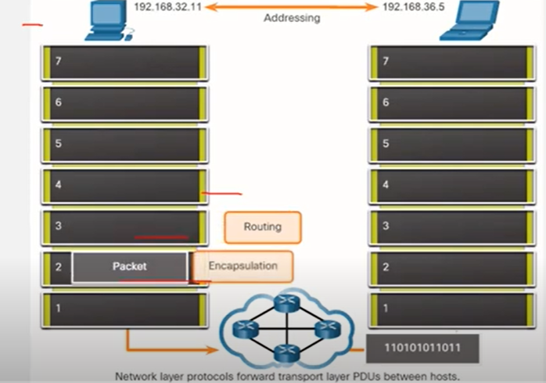

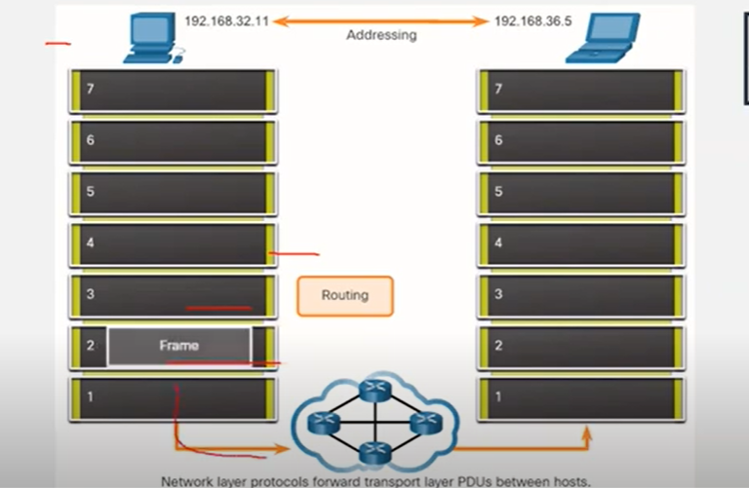

**Packet will get travelled to physical cable to the destinatination part and in the destination part steps strt from reverse from 1st step to 7th step**

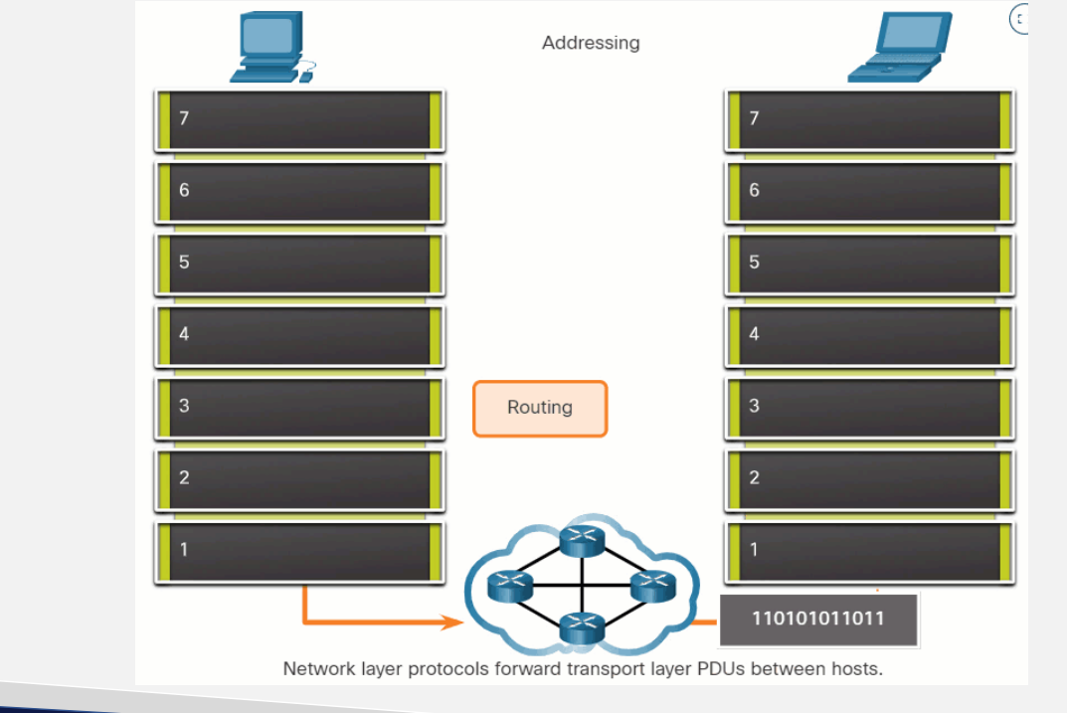

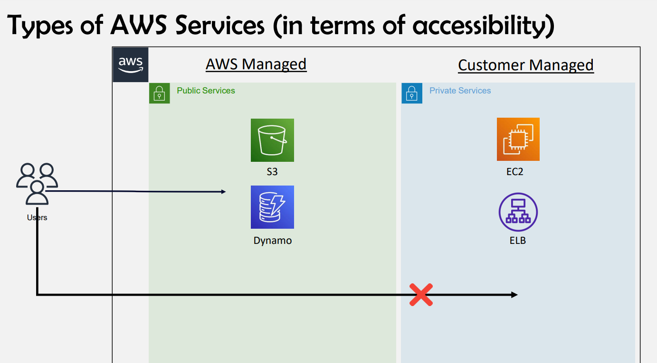

**Users can’t directly access EC2 & Elb as its customer managed until you create network**

* **Vpc will be must and should for accessing customer managed accessibility**

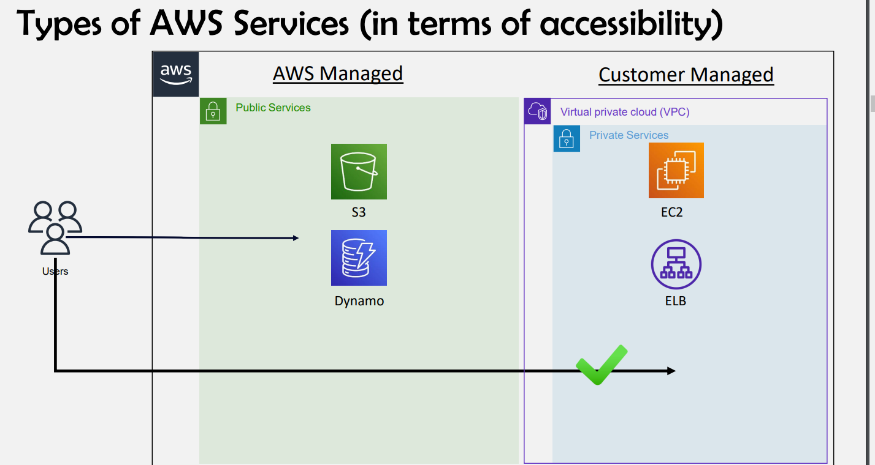

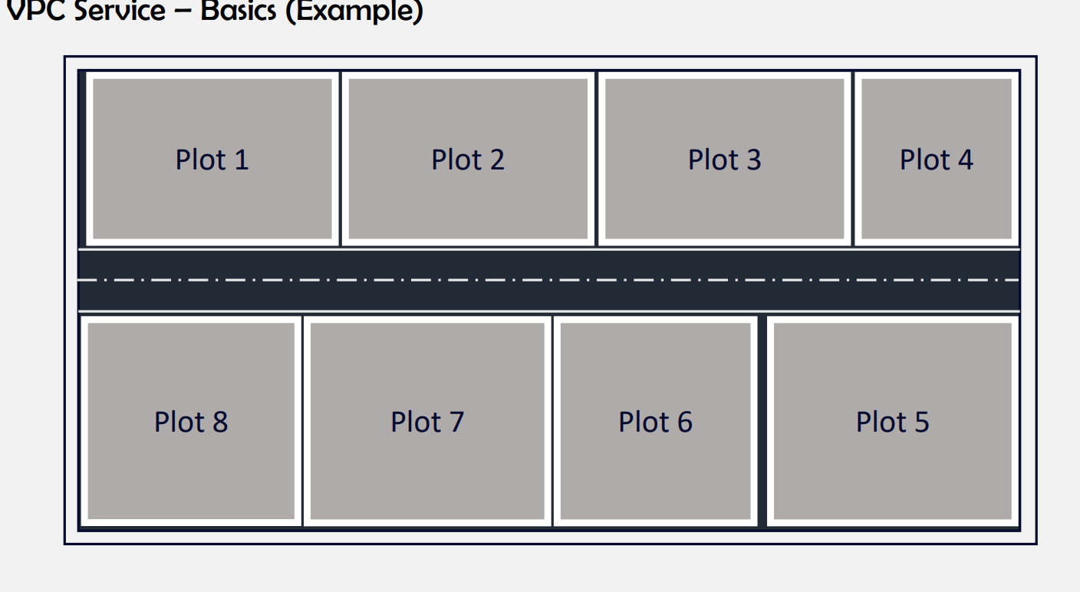

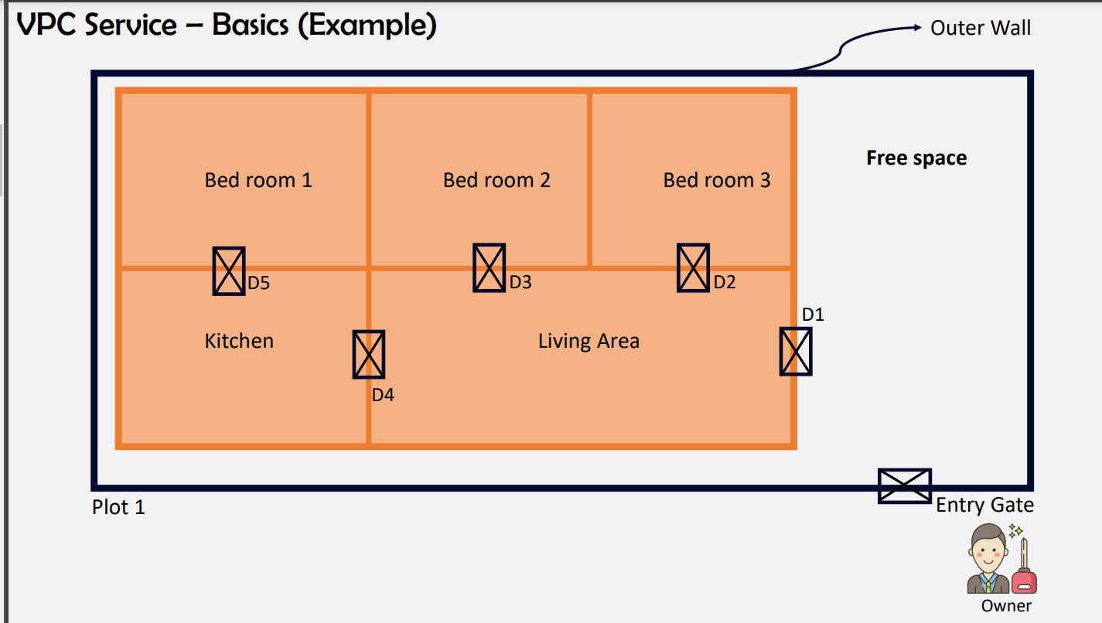

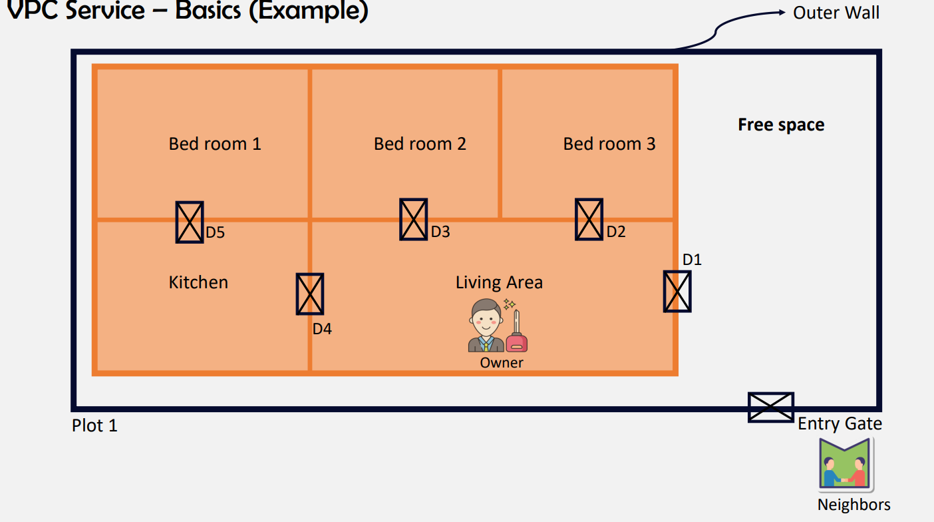

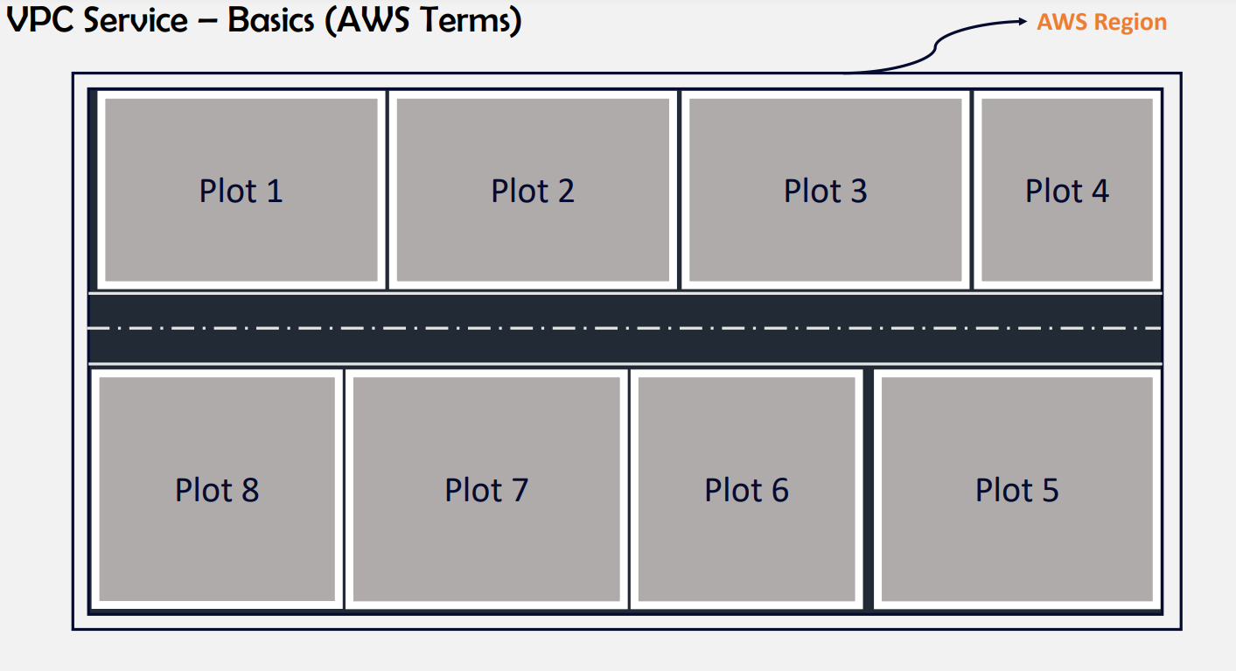

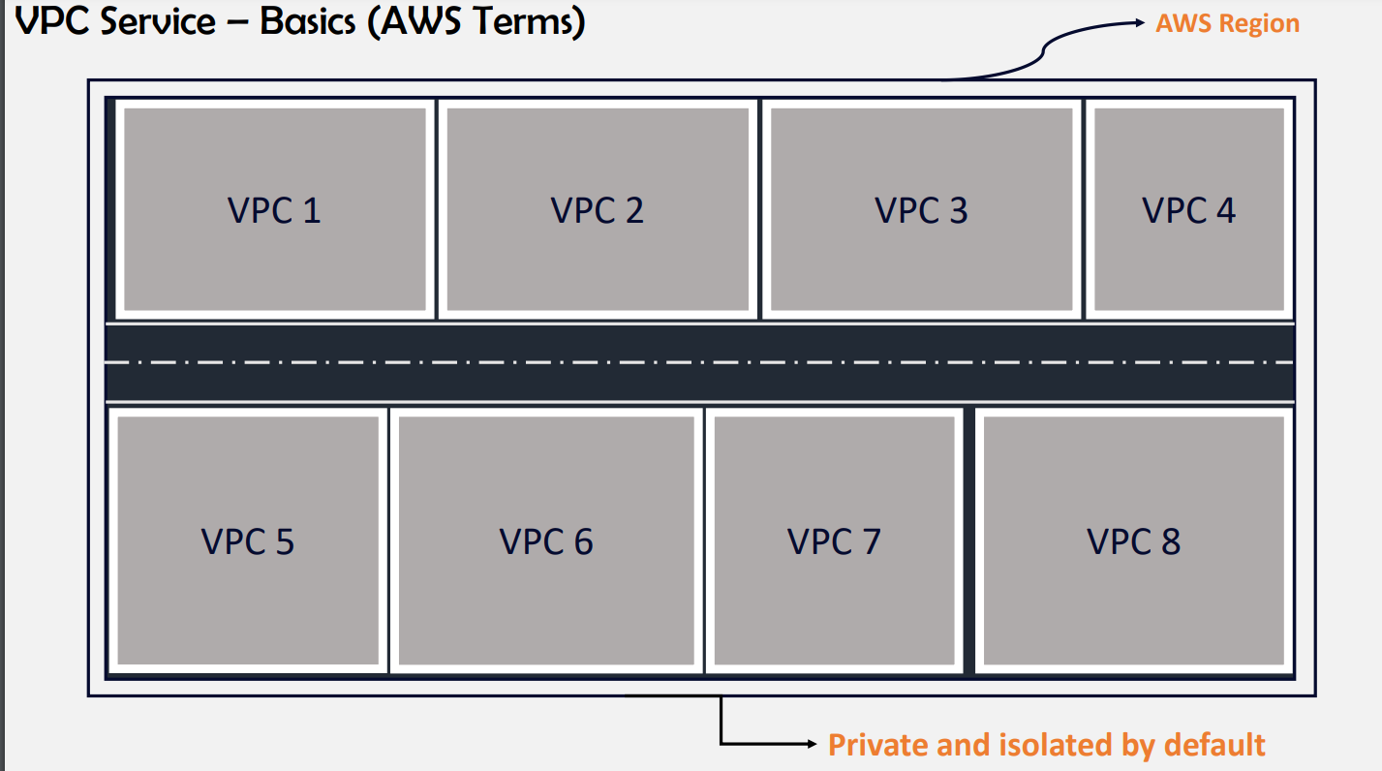

**If we want to connect one vpc to another vpc we have vpc peering option**

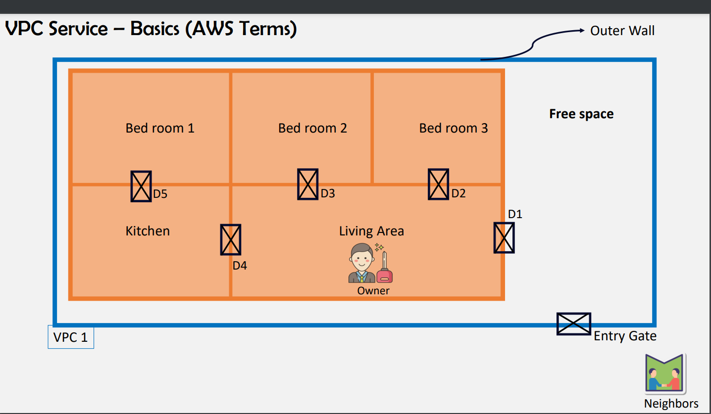

**For 1 region you can create 5 vpcs**

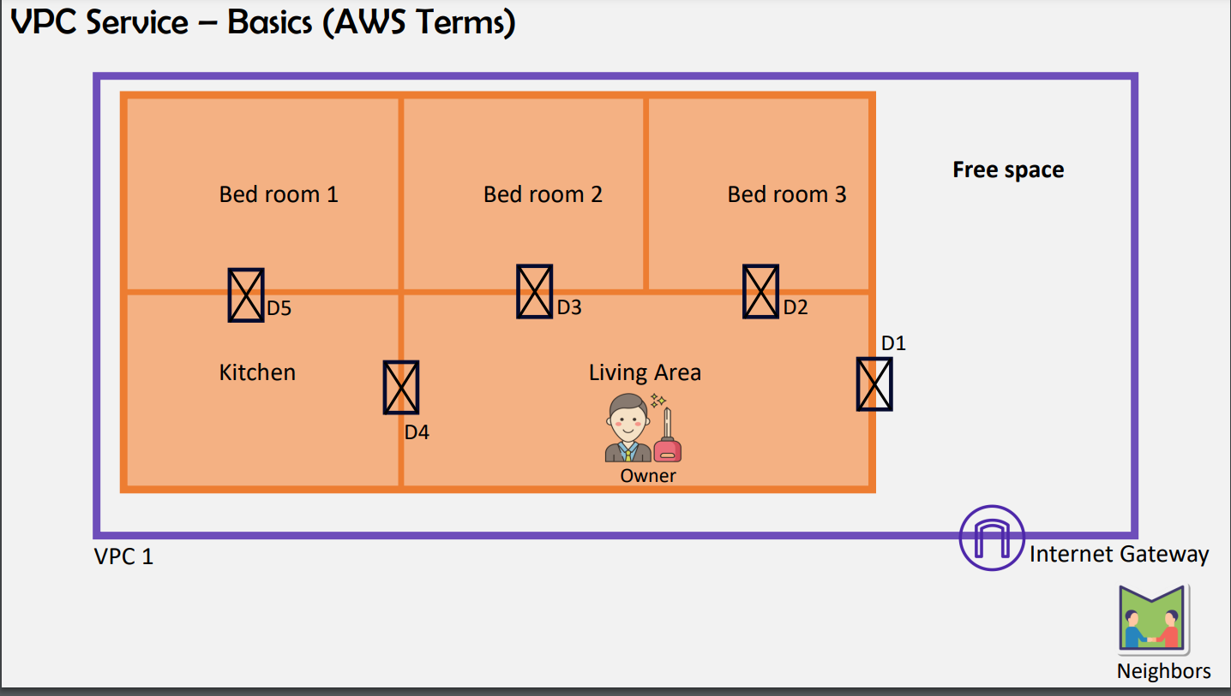

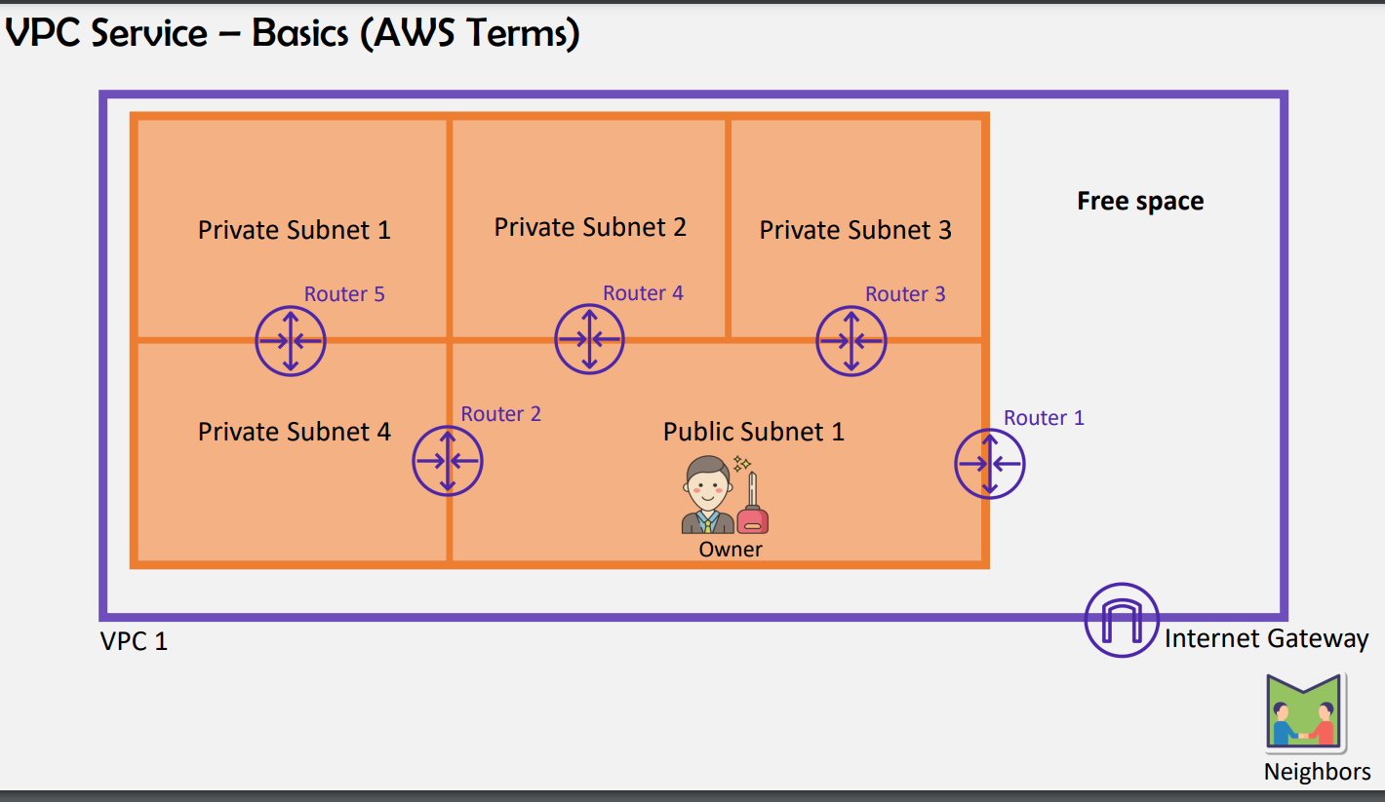

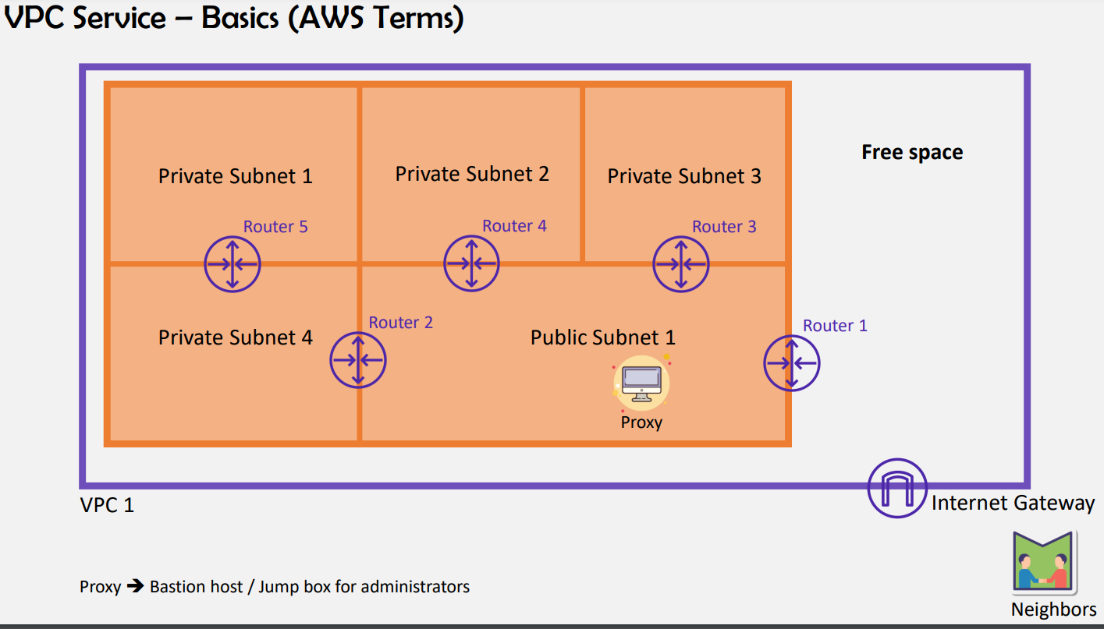

**We cant directly connect to private subnet**

* **If we want to connect we need to go to proxy in public subnet then only we can able to connect private subnets from public subnet**
* **Through proxy administrators will get connected to backend and database**
* **We can only create subnets but we cant say whether its public or private as we can only create subnets**
* **The subnet which is attached to igw is public subnet**
* **You can create only one route table for entire subnets or else you can create route table for each subnet or else for best practice will create one route table for public subnet and one route table for private subnets**

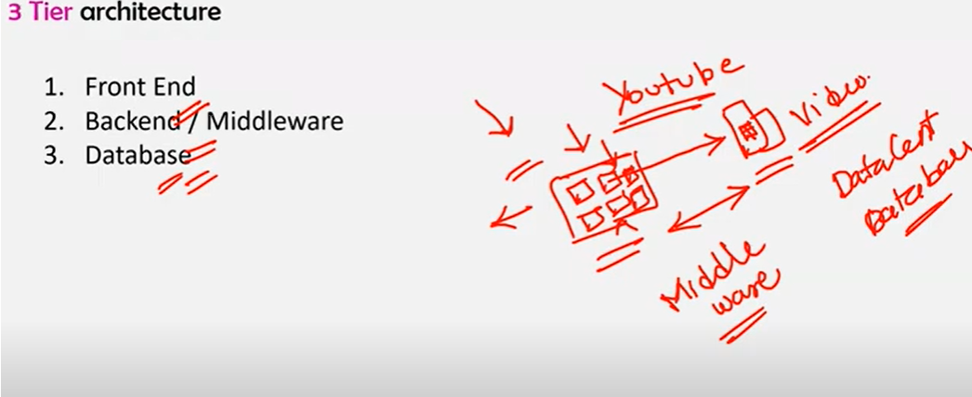

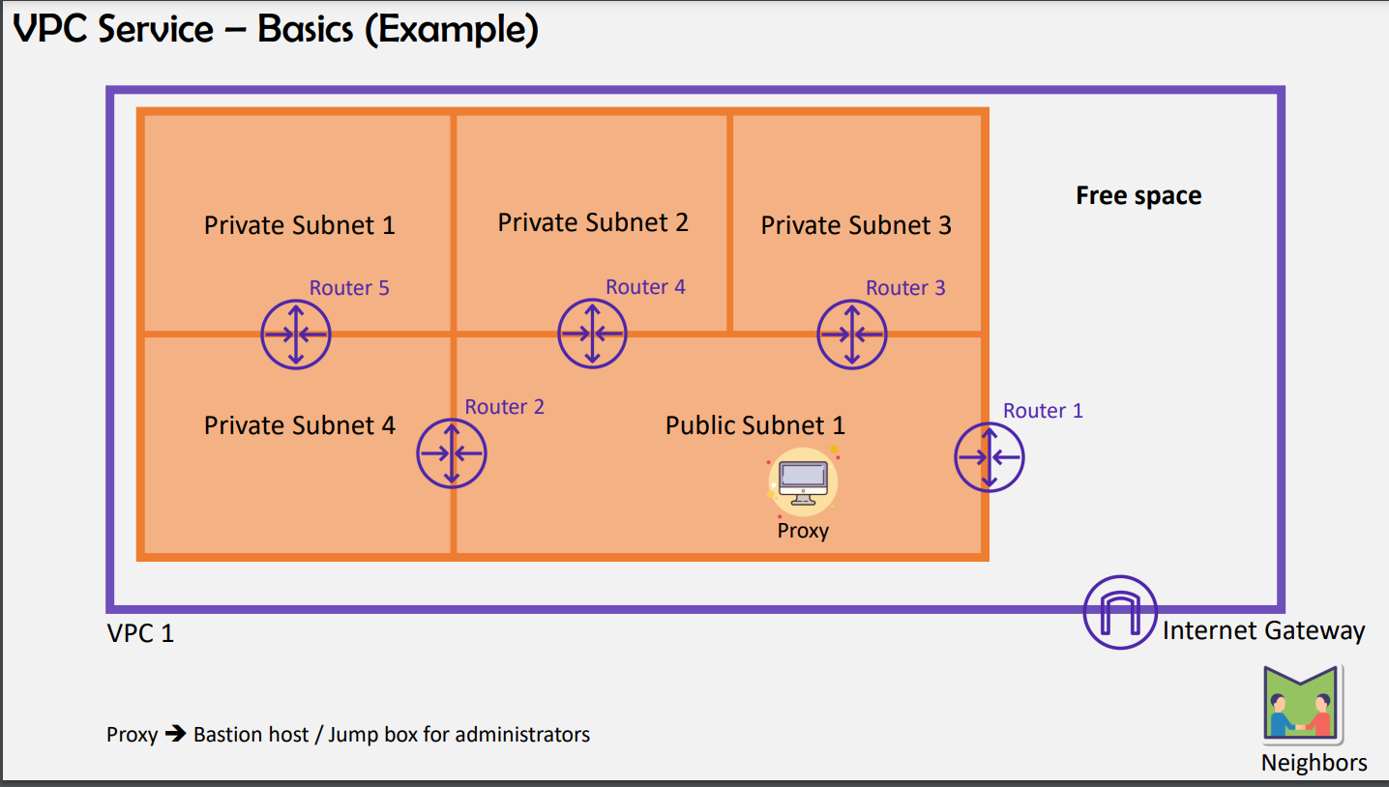

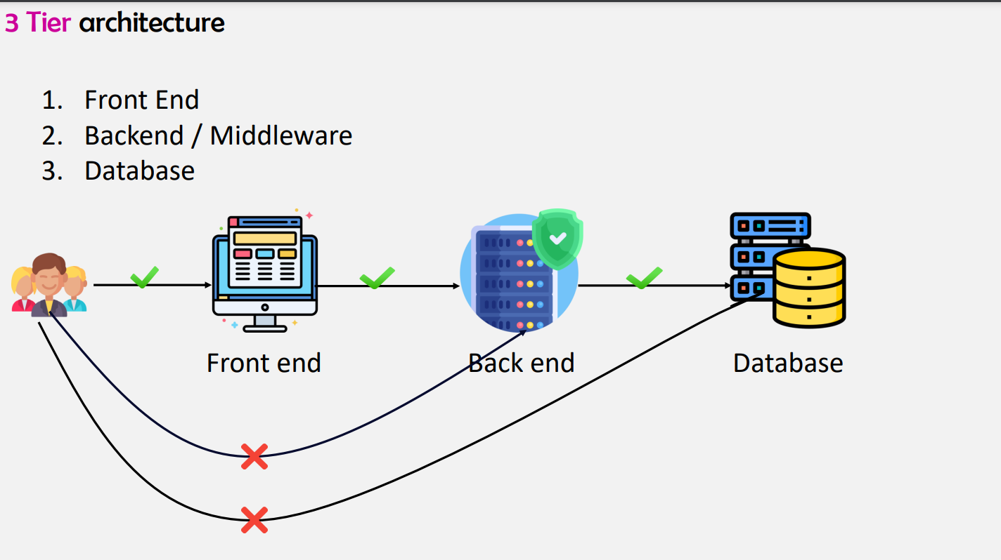

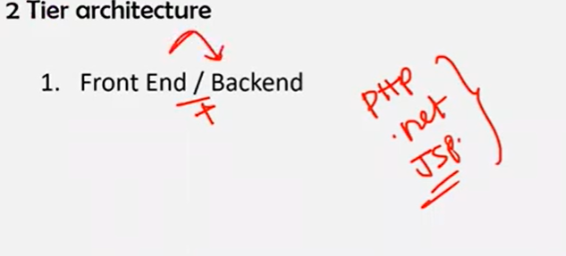

**For php ,.net , jsp we only required front end and backend**

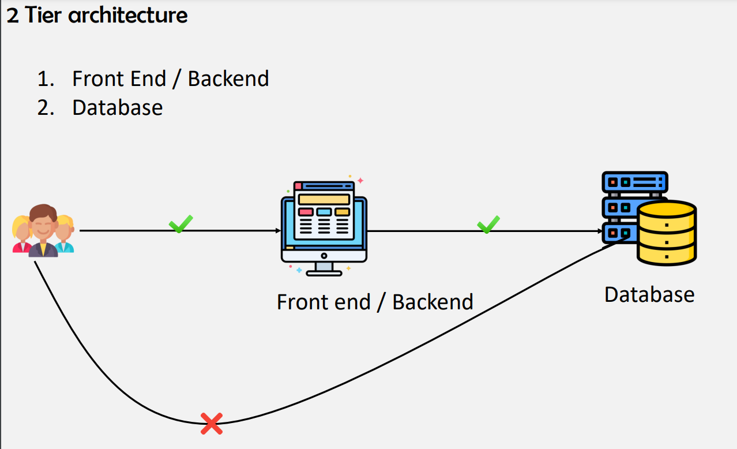

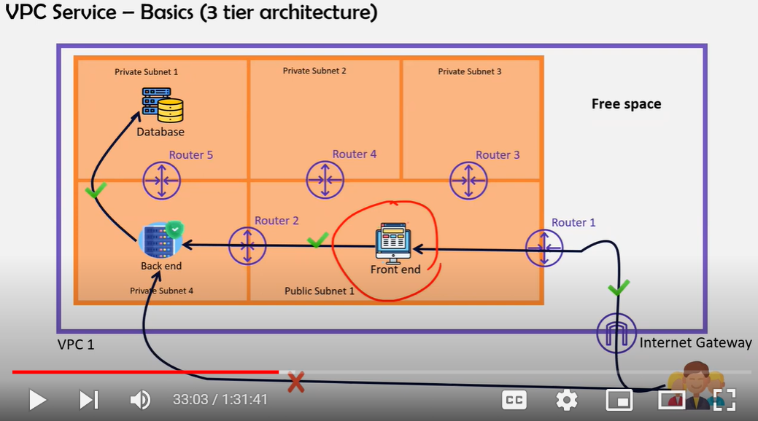

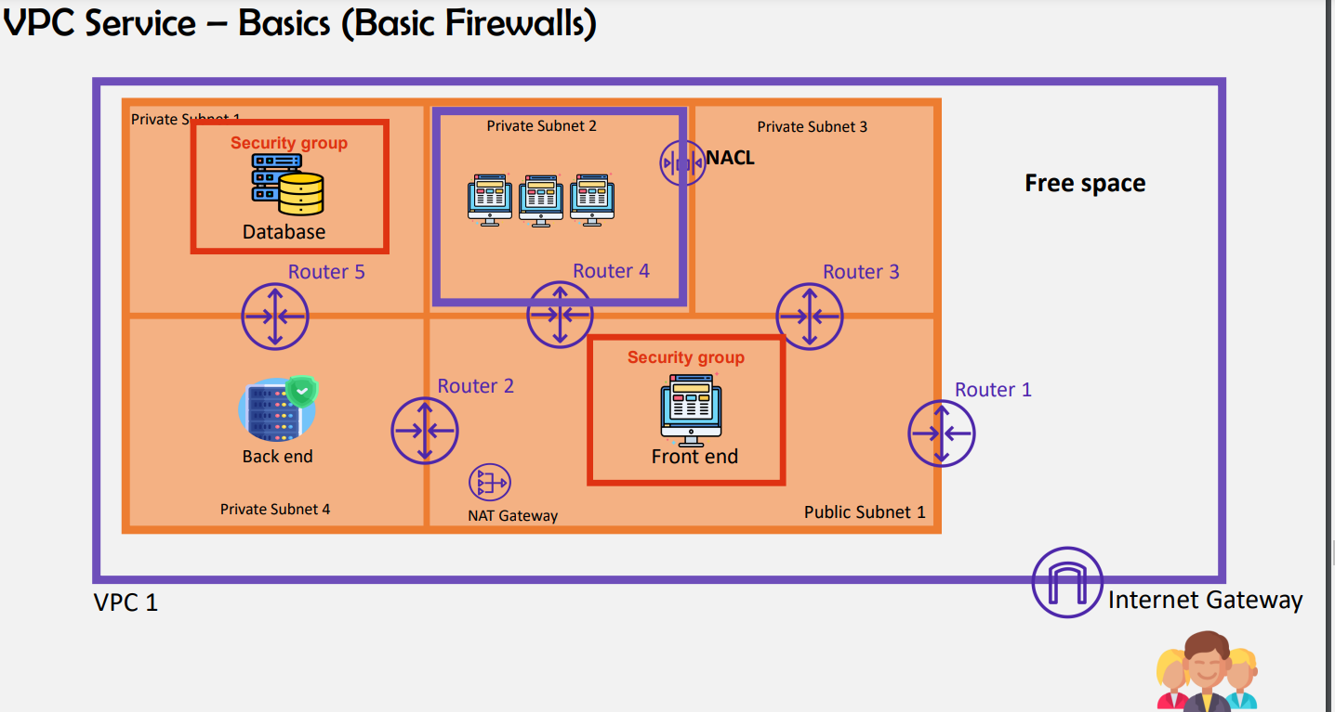

**IMP QUESTION :Natgateway will be placed in public subnet as it needs internet**

**If we place natgateway in private as it don’t have access to the internet we wont get private subnets data**

* **We need security protocols for hosting an application so for users http & https will be security protocols for ( end users) this will for those who connect from application layer**
* **For administrator who are going to configure http & https wont be useful for administrator**
* **Administrator – for linux machine he use SSH & for windows they need to use RDP he need to connect to these protocols these are called administrator protocols or developer protocols**

**2 types of firewall is needed to protect subnets 1. Security groups**

**2.NACL**

* **Security groups: security groups are server level firewall**
* **Nacl: subnet related firewall**

**Server level for each server we need to add each security group that might be difficult**

**So if we add subnet level firewall in that subnet if we have 50 servers that 50 servers will be having same security group as we are creating Nacl firewall(subnet level firewall)**

* **Free space is used for future purpose**
* **Whe Vpc is created by default NACL AND SECURITY GROUPS WILL GET CREATED**

**ORDER OF EVALUATION OF Security groups**

**IGW**

**RT**

**NACL**

**SG**

**SERVER**

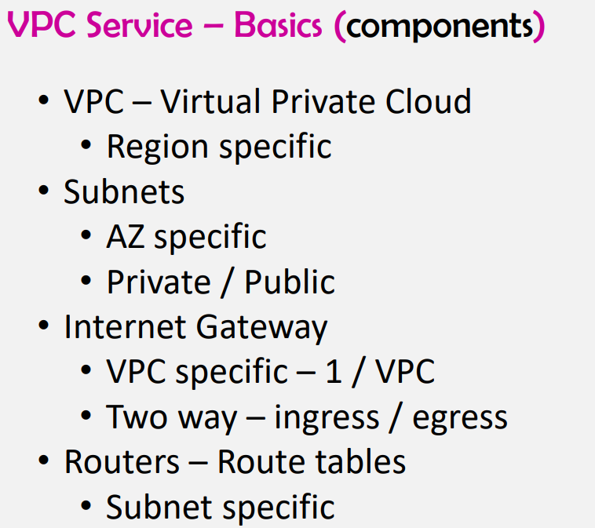

* **For 1 IGW you can attach 1vpc**

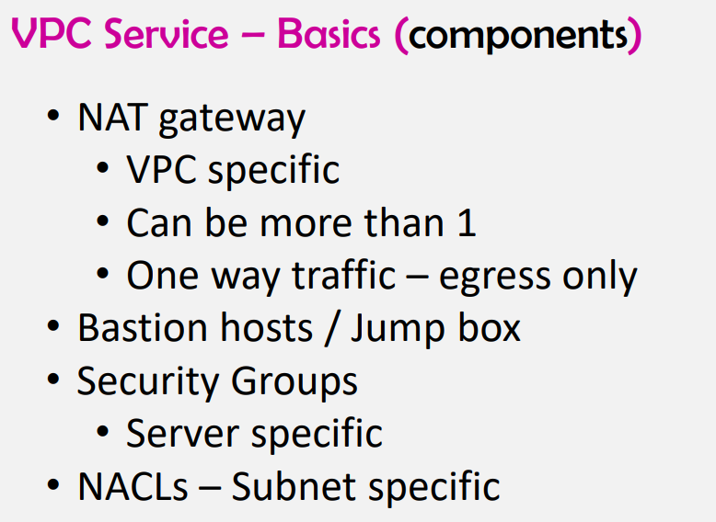

**For one natgateway you can attach more than 1 vpc**

* **Vpc is free**
* **Subnets is free**
* **Igw is free**
* **Natgateway is chargeable monthly (20$) for one natgateway yo will be having 10GBps of bandwidth**
* **(Bastion host/jumpbox/proxy) chargeable and its for the administrators purposewho wants to go in to the server and update the configurations**
* **NACL: Network Access control list**
* **Natgateway is different from Bastion host as its for administrators who want to connect to server and update the configurations**

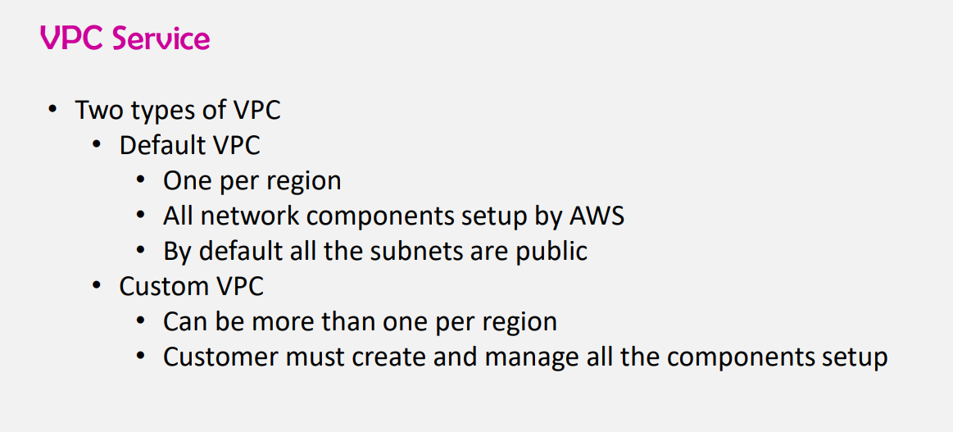

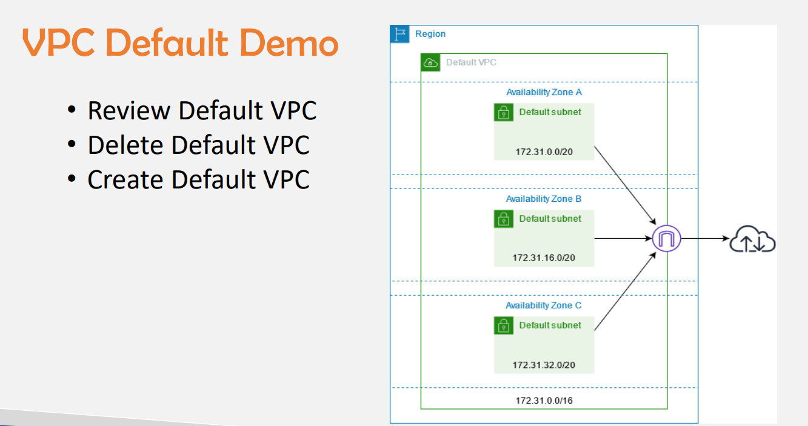

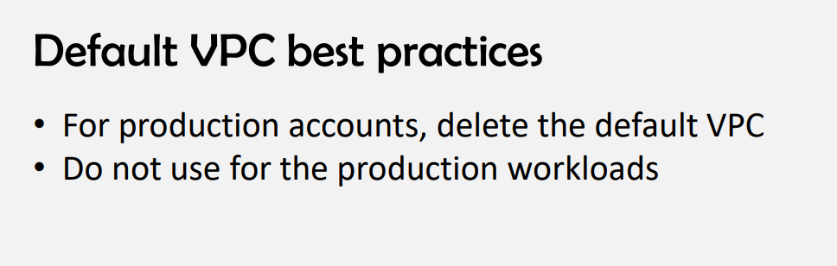

**For 1 region you can create only 5 vpcs (1 default +4 custom)**

* **If you want to delete default vpc you can create 5 vpcs for 1 region**
* **Vpc’s per region will be 5 if you want to increase the number of vpcs u need to drop a mail to support team with genuine reason**
* **For configuration of private subnets we use NATGATEWAY (for administrator purpose)just to download the dependencies .**